Setup New Workspace
- Find the source check out path from RTC Main Stream as shown on the print screen below
- To find the source check out path, right click on the source and click on properties
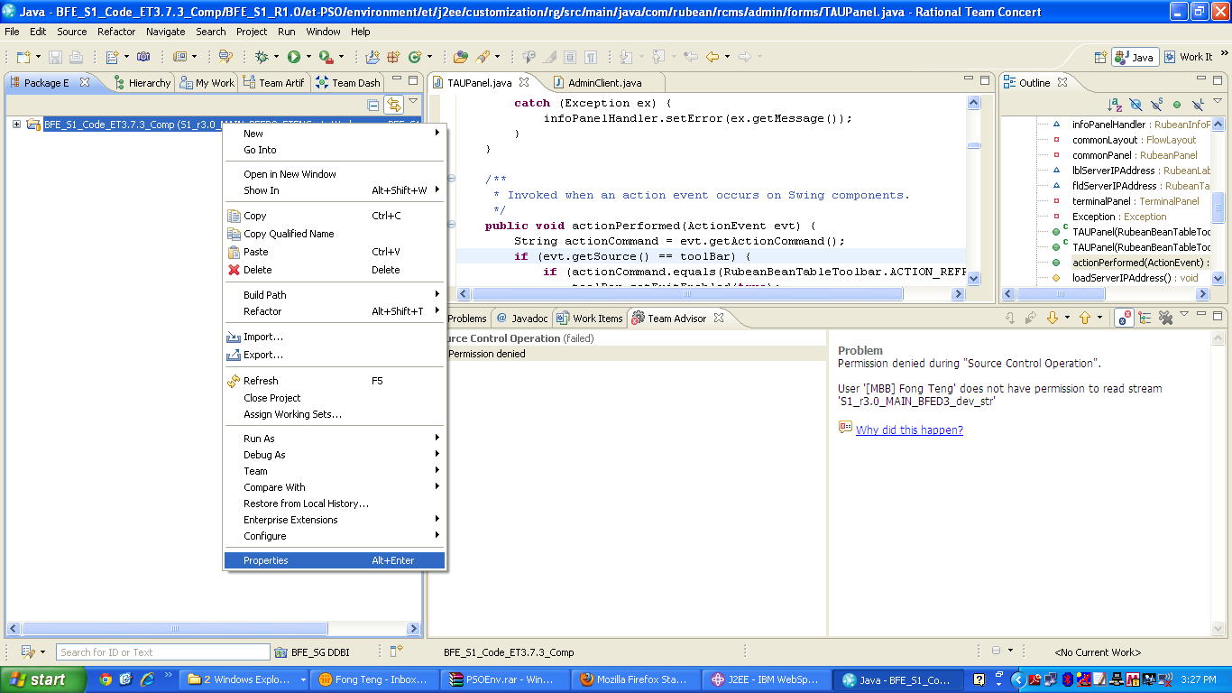

- The source check out path will be shown on the print screen below
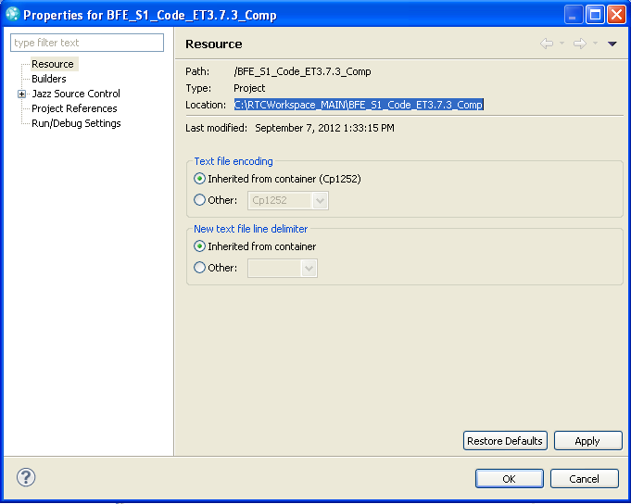

- Go to the highlighted path
- Double click on the BFE_S1_R1.0 as shown below

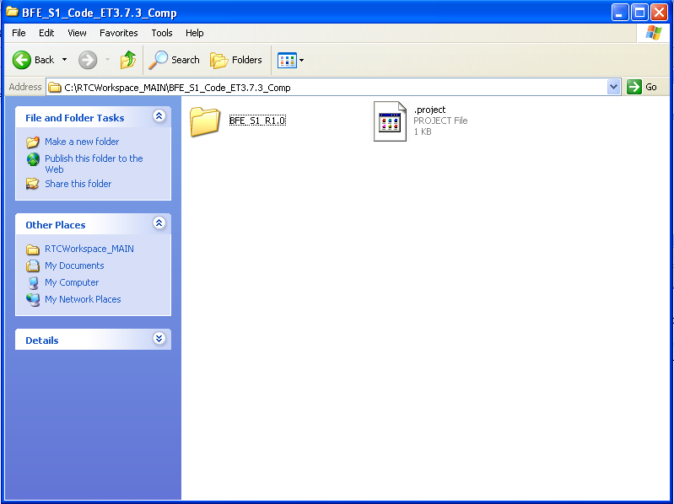

- Once click on the folder, you may see the files as shown on the print screen below
- Right click on the create_cust_env MS-DOS Batch File
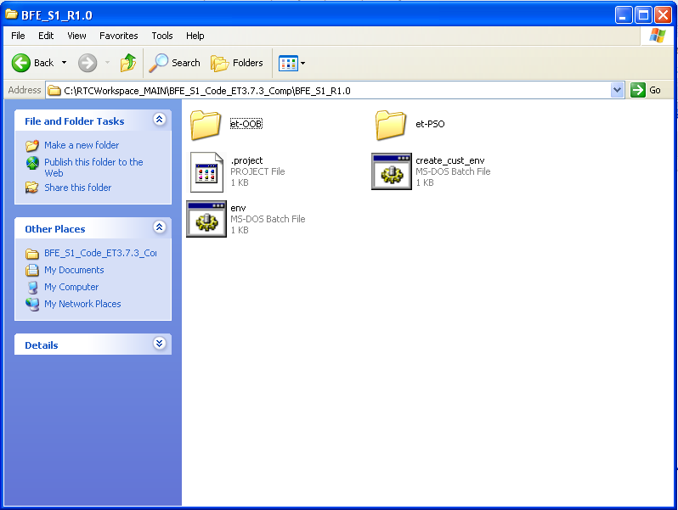
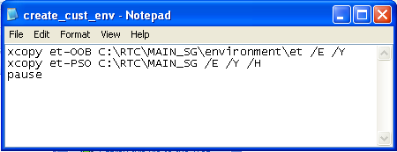

- create_cust_env MS-DOS Batch File will create a workspace at the C:\RTC\MAIN_SG path
- You may change the workspace path creation according to preference
- Double Click on the create_cust_env MS-DOS Batch File
- Press Y if the system prompt for Directory creation
- Once completed the rename the MAIN_SG to PSOEnv as shown below
- Move the PSOEnv from C:\RTC\ to C:\

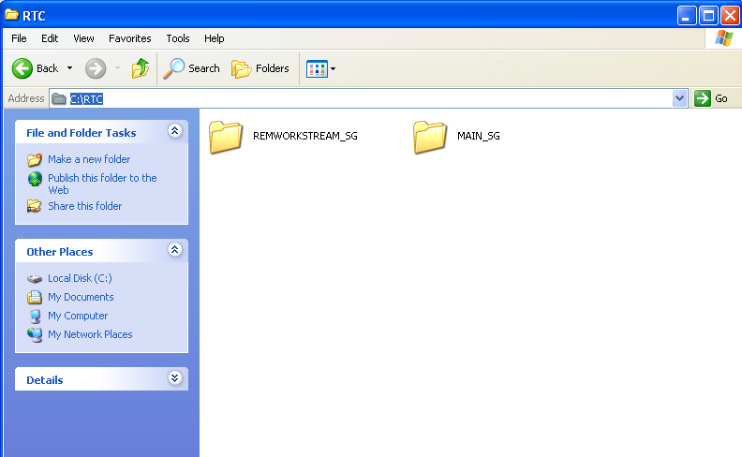

- Double click on run mapdrives
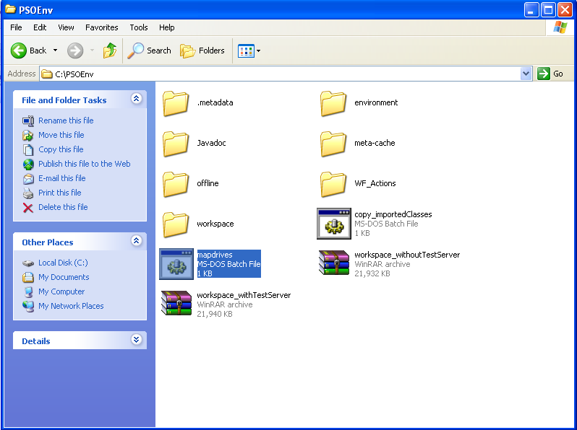

- Select Z:\workspace when prompted during the launch and Click OK to launch your workspace.
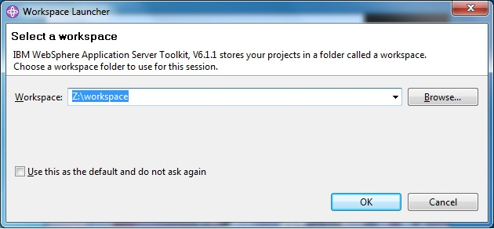

- Go to project and turn off Build Automatically option.

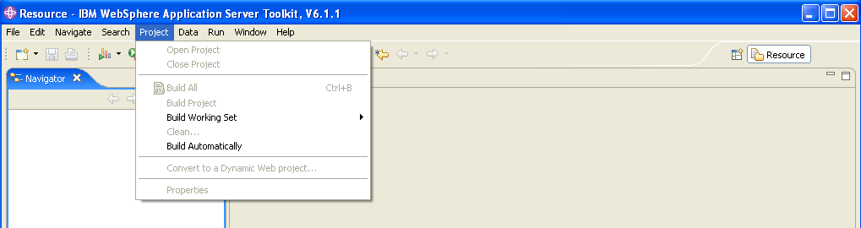

- Open J2EE perspective
- Setup the server runtime: Go to Window -> Preferences -> Server -> Installed Runtimes.

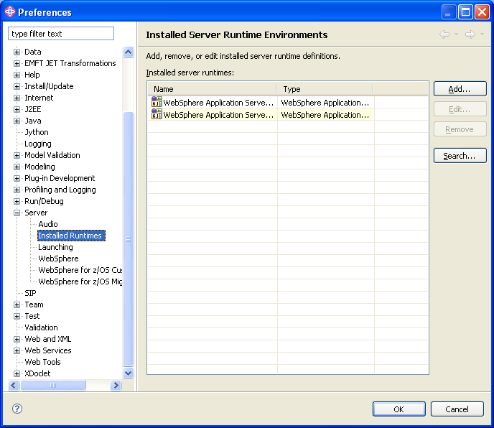

- Press Add. You will see below screen
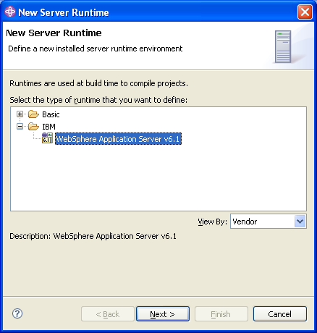

- Select the Websphere installation directory as shown below and press Finish.
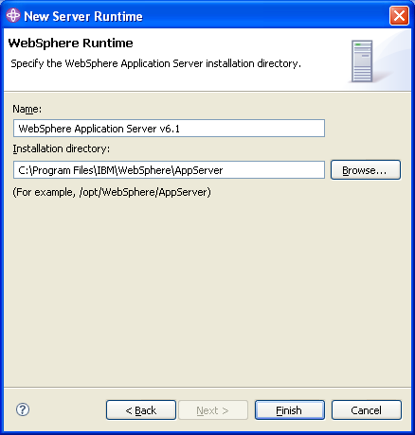

- Press OK to close the Preferences window.
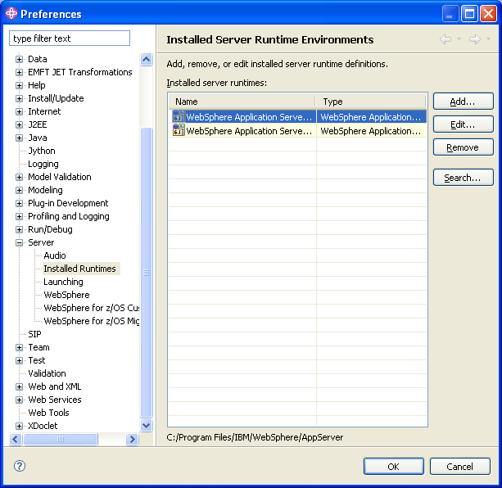

- Add existing profiles
1. Windows > Preferences > Server > Websphere

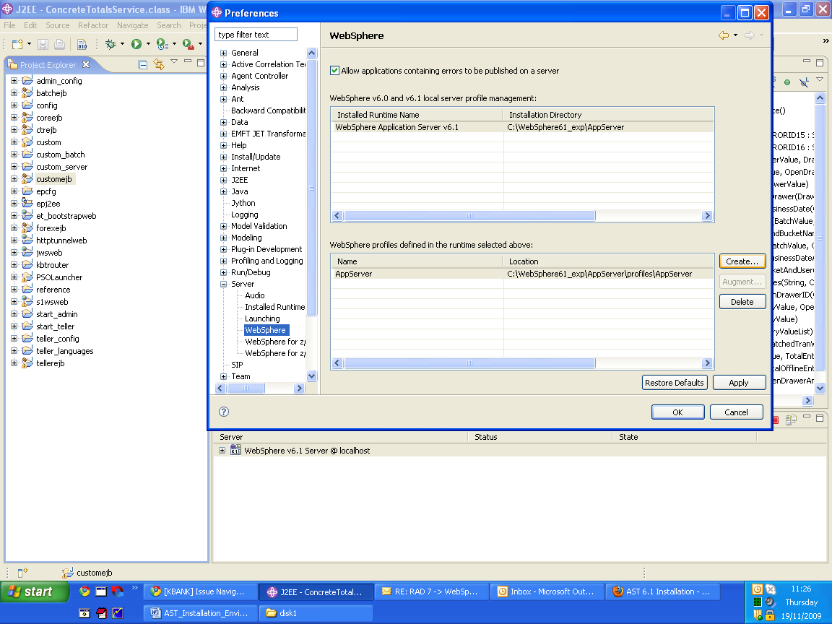

- Set the installed Java JRE to Websphere JRE as shown below (from Window -> Preferences -> Java -> Installed JREs)

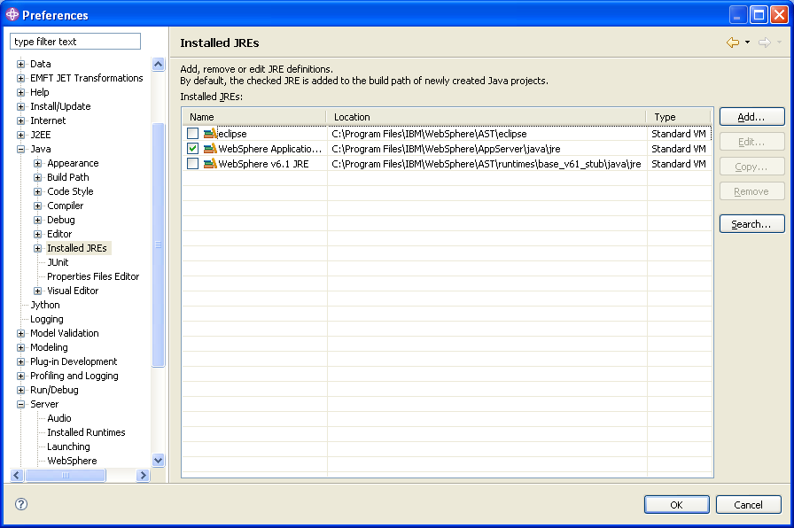
- Add Ant View from Window -> Show View -> Other -> Ant. Select Ant view and press OK.
  - Kindly refer to 05 ET Environment Setup.doc on Ant setup

- Remove and replace the following files

  - Remove the TAUPanel.java and TerminalPanel.java file

  - Add “ mbb.signon.dev.env = TRUE ” property in the “rg_admin.properties” file.
  - Delete “cashsignon.xml” file from the workflow.

  - Replace all the files from the attached folder. ( Please find the “NewEnvSetup.rar” from the attachement )

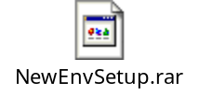

- Backup existing database before removing the database

- Restore the latest database

  - Go to Run type db2cmd
  - db2 drop database ET37_FST
  - db2 restore database ET37_FST from C:\
  - kindly insure the database is in your C:\ drive

- Please ensure the data source is create
  - Kindly refer to 05 ET Environment.doc on create data source and testing the database connectivity

- Run Ant builds
- Clean build all the projects. To do this from the Project menu of AST click on Clean.
- In the panel that opens up make sure that 'Clean all projects' option as well as 'start a build immediately' checkbox is selected

- Once step 29-31 has been completed

  - Kindly refer to 05 ET Environment.doc on Launch Application on the step to launch the Teller Administrator Menu and Teller Menu

